Title: Assessment Question 2

Course: E&EE Final Year

Lecture: Signal Processing

Date: 27/04/2001

Abstract

The specification requires a band-pass filter with pass-band from 2kHz to 2.5kHz; the design is constrained to an implementation with 17 coefficients (16th order) linear phase FIR filter. The principles stages of the theoretical window method filter design and it’s implementation are explicitly covered. The theoretical design is then compared against one which is provided by the PC-based design tools. Experimental evidence is offered to show the effectiveness of the PC-based design against it’s theoretical parent, through comparisons of amplitude and phase responses.

Introduction

The Fourier (or window) method design technique begins by selecting a brick wall amplitude response (lowpass, high-pass, band-pass or band-stop) and a zero phase response. It then accepts the inevitable fact that all digital filters have periodic transfer functions (with a period equal to the sampling frequency) and applies the inverse Fourier transform to a periodic version of the brick-wall response in order to determine the associated impulse response. The filter is implemented by selecting coefficients that give a close approximation to a delayed (and hence causal) version of the impulse response.
The main problem with this method of filter design is that the impulse responses corresponding to typical wanted frequency responses are infinite in extent. This means that a very large number of coefficients are needed to produce a good approximation of the frequency response and to make the filter causal. In practice, the number of coefficients is constrained for reasons of economy, and the associated truncation of the impulse signifies a deviation from the intended frequency response.
Let us first consider the effect of making the wanted transfer function periodic such that it repeats itself every sampling frequency. This means that a digital filter intended to realise the amplitude response A(f) shown in Figure 1.1(a) will actually achieve the amplitude response shown in Figure 1.1(b)

0
A(f)
A(f)
-f_{s}
f_{s}
0
0
Frequency
0
Frequency

Figure 1.1(a)

Figure 1.1(b)

We require the inverse Fourier transform of the transfer function corresponding to Figure 1.1(b) in order to determine what impulse response must be realised by the digital filter.
To recap on periodic functions of time we found that the coefficients of the exponential Fourier series of a time waveform f_{p}(t) of period T, and hence fundamental frequency f₀ = 1/T, were given by

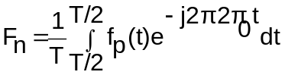

the Fourier transform is the same as its Fourier series, except that the lines of the Fourier series, are replaced by impulse functions whose weights are the same as the amplitudes of the lines.
Proceeding next to a periodic frequency function of period f_{s} = 1/t_{s} Hz (rather than a time function of period T seconds), the symmetry of the Fourier series and inverse Fourier transforms makes us deduce that the inverse Fourier transform of the periodic amplitude response of Figure 1.1(b) is a set of impulse functions t_{s} apart and whose weight is given by

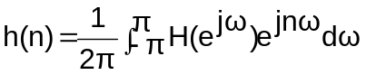

It follows that this is the fundamental design equation for determining the nth coefficient of a non-recursive filter using the Window method.

Principles of Methods

The PC program implements Finite Impulse Response Digital Filters through use of the window method. The filter response is influenced greatly by the precision (Q format) used by the C3M TMS32010 (digital signal processing equipment) for the arithmetic. The response shown by this program includes the effect of these rounding errors.
To achieve the PC-based response described in the end section of the results, the following data shown in bold type was entered into the Dsp/DFIR program.

- Enter filter type (lp, hp, bp, bs): bp

- Enter order (must be even): 16

- Enter lower c/o frequency (Hz): 0.2

- Enter upper c/o frequency (Hz): 0.25

- Enter window (R, HAN, HAM, or K): R

- Enter Q format for fixed point: 15

- Create frequency response graph (Y/N): Y

- Create TMS source (Y/N): Y
The Dsp program creates a TMS32010 assembler source file for the design. The assembler code can then be loaded and run on the C3M TMS32010 development system using the following sequence of events.

Again, the following data shown in bold type was entered into the PC, but this time interfaced through the C3M Monitor program.

- pcmon

- load fir

- go 200 e

The sample rate was altered using the left and right arrow keys using the numeric keypad, to a value of 10kHz. The response could then be analysed.

Results/Discussion of Results

SECTION 1- Theoretical window method based filter design

Let’s determine the FIR filter coefficients for a 16th order band-pass filter with pass-band between 2 and 2.5kHz for a sampling frequency of 10 kHz

- Since f_{s} = 10 kHz, the cut-off frequencies in normalised form are 0.2 and 0.25, or for calculation ω_{c1} = 0.4π and ω_{c1} = 0.5π rad/sec.

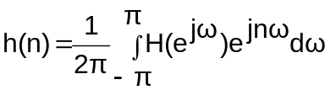 Equation 1.1

In the passband H(e^{jω}) = 1 (ideally and hence the output is simply the input delayed by a given amount). The passband of the filter is in the range – π to +π, or to be more precise the passband occurs from – 0.5π to -0.4π and from 0.4π to 0.5π as shown in the diagram below.

ω - π -0.5π -0.4π 0.4π 0.5π π
f -f_{s}/2 f_{s}/2

Figure 1.1(c)

By taking this information into consideration, Equation 1.1 becomes

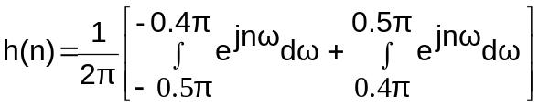 Equation 1.2

For analytical purposes Equation 1.2 is useless in it’s current form. The integrals can be solved to derive the impulse response in it’s simpler form.

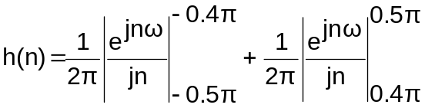

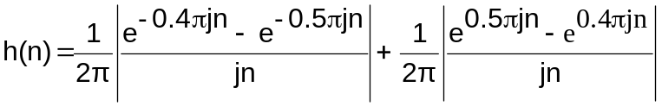

Collecting terms under a common denominator we have:-

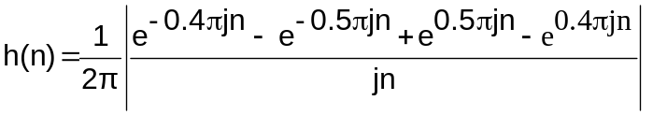

With Euler’s relation in mind the equation is rearranged

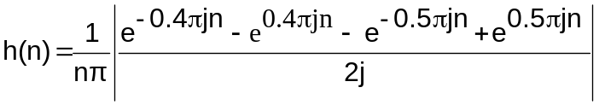
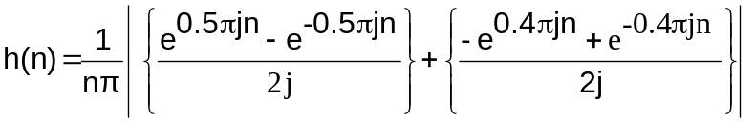

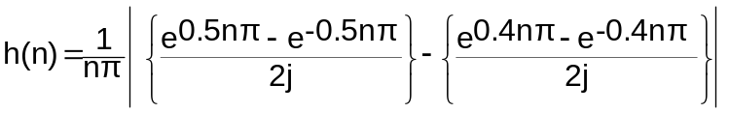

Using Euler’s relation
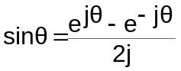
we find

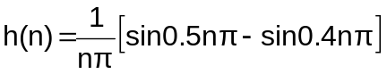 Equation 1.3

A 16th order filter will have n running from -8, -7, -6, .. 0 .., +8.
Using Equation 1.3, the discrete impulse response values of this 16th order filter can be calculated.

n | H(n)
-8 | 0.02339
-7 | -0.07220
-6 | -0.05046
-5 | 0.06366
-4 | 0.07568
-3 | -0.04374
-2 | -0.09355
-1 | 0.01558
0 | 0
1 | 0.01558
2 | -0.09355
3 | -0.04374
4 | 0.07568
5 | 0.06366
6 | -0.05046
7 | -0.07220
8 | 0.02339

The system described is a 16th order system, hence the order (m) = 16. By adopting a rectangular window the impulse response sequence {h(n)} is truncated by setting n< -m/2 and where n< m/2.

h(n) = 0 -16/2< n <16/2

Hence

h(n) = 0 -8< n <8

Using a graph plotting package, the impulse response of the 16th order filter can be realised.

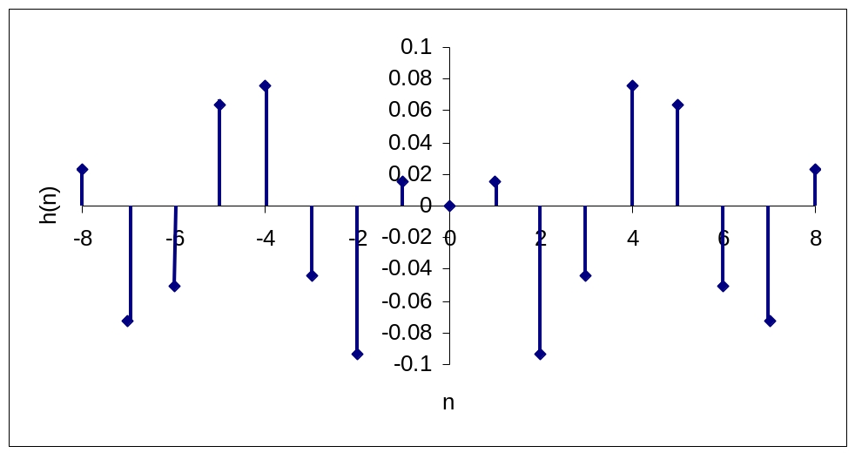
Figure 1.2(a): Impulse Response h(n) of a 16th order FIR bandpass filter

The sequence must be delayed by m/2 samples to ensure causality. The first sample (n= -8) occurs at n=0; all prior samples are set to zero.
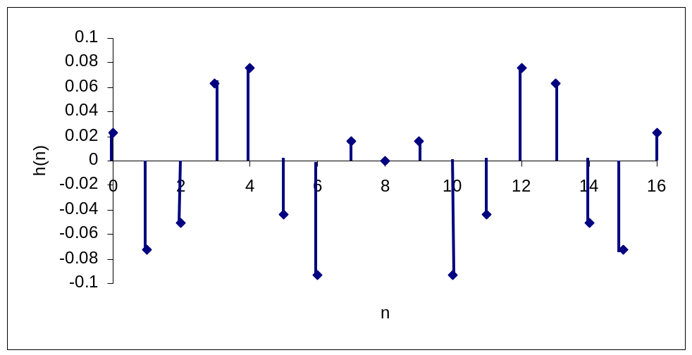
Figure1.2(b): Impulse Response h(n) of a 16th order FIR bandpass filter delayed by 8 samples i.e. m/2, where m is the order of the filter.

The filter realisation is shown in Figure 1.3.
0.02339
t_{s}
t_{s}
t_{s}
t_{s}
t_{s}
t_{s}
t_{s}
t_{s}
t_{s}
t_{s}
t_{s}
t_{s}
t_{s}
t_{s}
t_{s}
t_{s}
-0.07220
-0.05046
0.06366
0.07568
-0.04374
-0.09355
0.01558
0.01558
-0.09355
-0.04374
0.07568
0.06366
-0.05046
-0.07220
0.02339

Figure 1.3: Realisation of the 16th order non-recursive filter
Using the frequency response equation given by the summation:

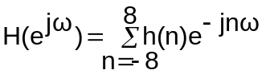

Substituting the filter coefficients achieved in the previous exercise we obtain

H(e^{jω}) = 0.02339 e^{j8ω} –0.07220 e^{j7ω} –0.05046 e^{j6ω} +0.06366 e^{j5ω}
+0.07568 e^{j4ω} – 0.04374 e^{j3ω} – 0.09355 e^{j2ω} +0.01558 e^{jω} + 0
+0.01558 e^{-jω} -0.09355 e^{-j2ω} -0.04374 e^{-j3ω} +0.07568 e^{-j4ω}
+0.06366 e^{-j5ω} –0.05046 e^{-j6ω} –0.07220 e^{-j7ω} +0.02339 e^{-j8ω}

Gathering terms with the same coefficients.

H(e^{jω}) = 0.02339 (e^{j8ω}+ e^{-j8ω}) –0.07220 (e^{j7ω} + e^{-j7ω}) –0.05046 (e^{j6ω} + e^{-j6ω})
+0.06366 (e^{j5ω} +e^{-j5ω}) +0.07568 (e^{j4ω}+ e^{-j4ω}) – 0.04374 (e^{j3ω} + e^{-j3ω})
- 0.09355 (e^{j2ω} +e^{-j2ω}) +0.01558 (e^{jω} +e^{-jω})

Using Euler’s relation

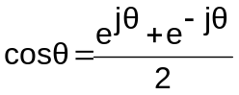

the transfer function simplifies to

H(e^{jω}) = 0.04678 cos7ω – 0.10092 cos6ω +0.12732 cos5ω +0.15136 cos4ω
– 0.08748 cos3ω -0.1871 cos2ω +0.03116 cosω

This can be evaluated as a function of frequency and plotted. Alternatively, using MATLAB, the coefficients can be entered and then use the command for obtaining the frequency response, that is

MATLAB SCRIPT 1.1

ac = [0.0234 -0.0722 -0.0505 0.0637 0.0757 -0.0437 -0.0935 0.0156 0 0.0156 -0.0935 -0.0437 0.0757 0.0637 -0.0505 -0.0722];

bc=[1];

freqz(ac,bc);

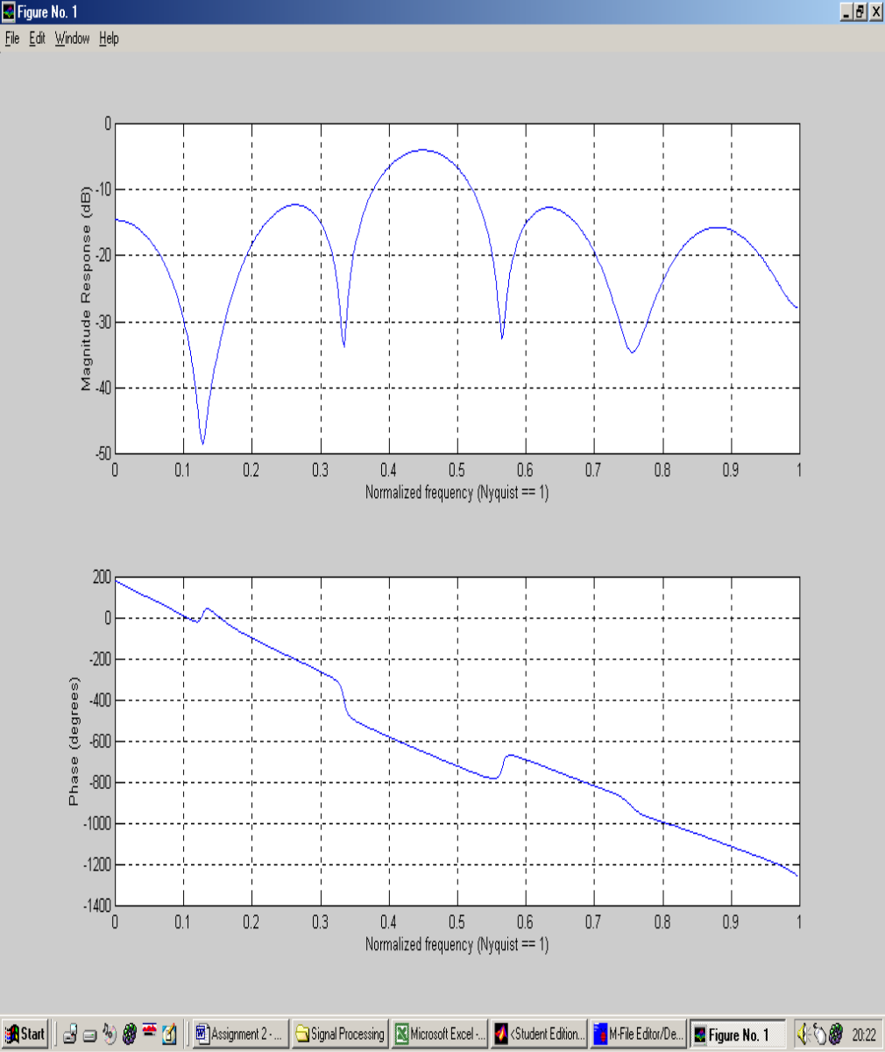

Figure 1.4: MATLAB deduced frequency response for the given impulse response in the table above

Looking at the frequency response in Figure 1.4, the pass-band occurs between the normalised frequencies of 0.4 and 0.5. This relates to the required cut-off frequencies of 0.4π and 0.5π rad/sec as stated at the start of Section 1. The pass-band is not flat, it’s shape is more elliptical. On close inspection the elliptical form does lie within the 3dB constraints. The side lobes are well down in amplitude in comparison to the peak of the central lobe (greater than 3dB) and hence can be considered filtered out (a more detailed look into the amplitude response is presented in SECTION 2).
Taking a look at the Phase response graph it can be seen that within the normalised pass-band frequencies the phase response is linear. Outside the pass-band frequencies non-linearity’s occur. It can be seen that these non-linear effects occur in direct correspondence with the two side lobes either side of the central lobe on the amplitude response. The phase however does not veer away to any significance from it’s linear directionality.

SECTION 2 – DSP PC based filter design

n | H(n)
-8 | 0.02339
-7 | -0.07220
-6 | -0.05046
-5 | 0.06366
-4 | 0.07568
-3 | -0.04374
-2 | -0.09355
-1 | 0.01558
0 | 0.10000
1 | 0.01558
2 | -0.09355
3 | -0.04374
4 | 0.07568
5 | 0.06366
6 | -0.05046
7 | -0.07220
8 | 0.02339

The above filter coefficients were generated when specifying to the DFIR program that a rectangular window response was required. All the coefficients (with the exception of the response for n = 0) are exactly the same as those calculated manually in the previous table using Equation 1.3.

n | H(n)
-8 | 766.00000
-7 | -2366.00000
-6 | -1653.00000
-5 | 2086.00000
-4 | 2480.00000
-3 | -1433.00000
-2 | -3065.00000
-1 | 510.00000
0 | 3277.00000
1 | 510.00000
2 | -3065.00000
3 | -1433.00000
4 | 2480.00000
5 | 2086.00000
6 | -1653.00000
7 | -2366.00000
8 | 766.00000

By selecting a Q format of 15 the original filter coefficients are scaled by 2¹⁵ (32768). This is the maximum Q format available because the design system can handle a maximum word length of 16 bits.

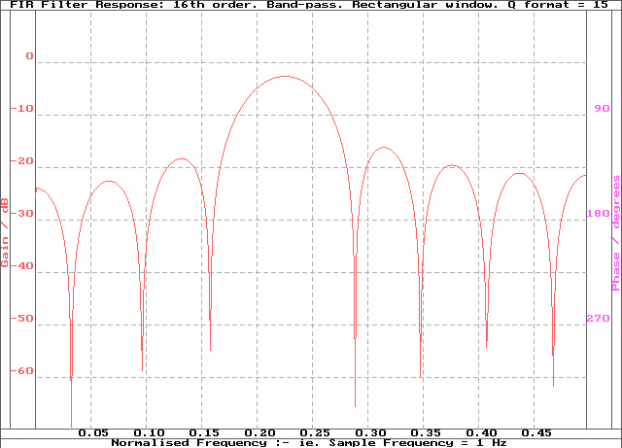

Figure 2.1: Ideal amplitude response graph using the DSP PC-based design package

The ideal response achieved by the PC-based design package is shown in Figure 2.1(very much equivalent to the MATLAB derived amplitude response). This is the amplitude response in the normalised frequency range 0 (d.c) to 0.5 (Nyquist frequency), the phase response is not plotted by this particular package. The shape of the amplitude response is of particular interest. The central lobe is symmetrical about the normalised frequency 0.225 ± 0.075. The gain of the central lobe decreases from approximately –3dB at the centre of the central lobe (normalised frequency 0.225) to –5dB at the normalised frequencies of 0.2 and 0.25. These are the inputted cut off frequencies required by the PC-based design tools; 0.2(normalised lower cut off frequency), 0.25(normalised upper cut off frequency). The amplitude response for frequencies outside this window are ≥3dB down from the pass-band, hence are deemed cut out by the system, which is to be expected.
The gain level at which the amplitude response is considered attenuated occurs at 7dB down from unity gain. If the amplitude of the response is below this level, then it assumed cut out by the system. The highest gain the upper and lower side lobes achieve is –17dB. At this such a low gain level, they are insignificant in the attenuation of an input signal. However, the shape and location of the lower side lobes has a knock on effect, on the phase response. An amplitude response as such allows a linear phase response to exist within a filtering system.

The required frequency response obtained from the PC-based program can be loaded and run on the C3M TMS32010 development system. The real-time performance of the PC-based design system was examined.

Frequency(kHz) | Input Amplitude(V) | Output Amplitude(V) | Phase(Deg)
0.5 | 2 | 1 | 100
2.0 | 2 | 1.5 | -120
2.5 | 2 | 1.5 | -230
3.0 | 2 | 1 | -360
4.5 | 2 | 1 | -1000
6.0 | 2 | 0.5 | -1200
7.0 | 2 | 0.5 | -1300
8.0 | 2 | 0 | -1500
9.0 | 2 | 0 | -1800
10.0 | 2 | 0 | -2100

The amplitude and phase response of the filter were investigated; tabulated over a suitable range of frequencies ranging from 0.5kHz – 10kHz (as shown in the above table).

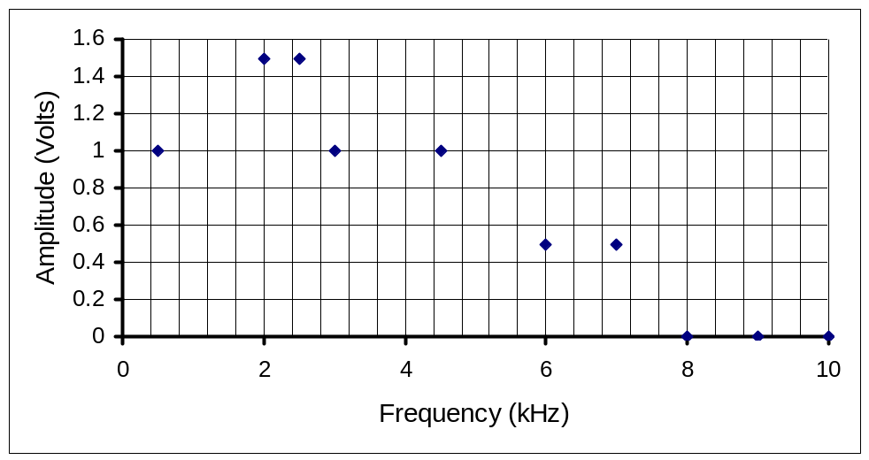
Figure2.2(a) Approximated Amplitude Response of the Real-Time Digital Filter

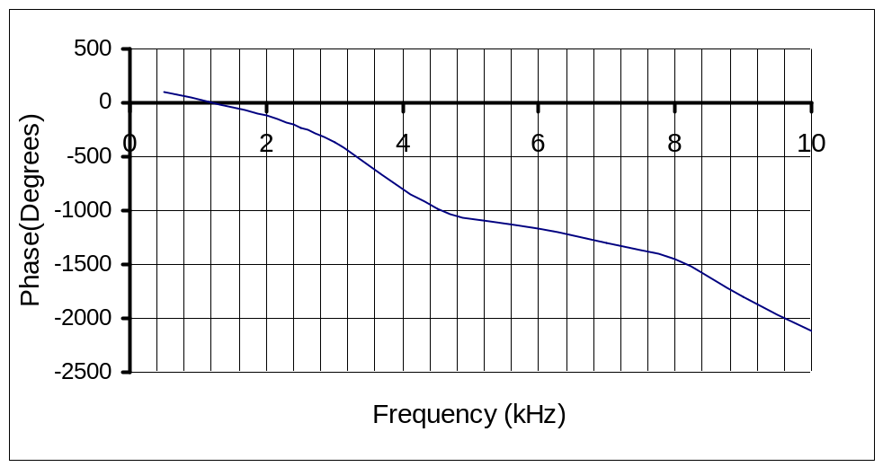
Figure2.2(b) Approximated Phase Response of the Real-Time Digital Filter
The stem graph of Figure 2.2(a) shows that the amplitude response is at it’s maximum value at frequencies of 2.0 and 2.5kHz. This causal plot shows, at frequencies higher and lower than these pass-band frequencies the response falls off. The stems indicate the peak of the lobes. Beyond 7kHz the amplitude response dies down to zero.
The phase response of Figure 2.2(b) can be considered linear over the full range sampling range. The phase angle decreases from it’s initial height of 180 degrees down to –2200 degrees at 10kHz. There is a noticeable dip in the phase at 5kHz, the gradient is less severe until 8kHz, where the gradient steepens.

Conclusion

The designer was required to create a linear phase 16th order band-pass FIR filter with pass-band from 2.5 2kHz to 2.5kHz. Use of the Window method allowed a filter with response (shown in Figure 1.4) to meet the specification. The best aspect of the non-recursive filter response is the near linear phase response in the pass-band. For the filter to achieve linear phase in the pass-band the amplitude response suffers. The amplitude response in comparison to the theoretical brick wall response pales in comparison. The large side lobes are undesirable, but because the magnitude of the side lobes are well down in gain in comparison to the pass-band it can be said that their effect is minimal. The gain of the magnitude response is in the required pass-band 0.4π and 0.5π rad/sec. The amplitude of the response in the pass-band ranges from approximately –4 to –7dB. The pass-band is not at the unity gain level; the specification does not inform the designer what the pass-band gain level should be, hence this observation can be dismissed.
If one were to overlay the stem graph of Figure 2.2(a) (C3M TMS32010 development system response) with that of the desired amplitude response of Figure 2.1, there is a great deal of observable similarities between the two. Because the amplitude response of the practical filter (and the phase response for that matter) are plotted for 10 discrete frequencies (where the peaks of the lobes occur) are not exact. As an estimation, the amplitude response is good. The peaks that have been plotted do correspond to those of the desired response. What isn’t known is, how well the magnitude of the lobes of Figure 2.1 at frequencies higher than 5kHz compare with that of the approximated response of 2.2(a) (in any case it is of no relevance).
The approximated phase response of Figure 2.2(b) compares well against that of the theoretical deduced response (figure 1.4). Because the graphical tool used smoothes the plotted function, the phase response of Figure 2.2(b) is only an approximation. The MATLAB deduced response more accurately shows the steps/non-linearity’s. Both the MATLAB deduced and experimental based function do exhibit a good linear response in the specified pass-band.
Overall the response developed on the C3M TMS32010 system is satisfactory. Not extracted to any great detail, the amplitude and phase responses are approximations but are plausible. By selecting a larger range of test frequencies, it would be seen that the response generated by the C3M TMS32010 system would be accurate to the desired response.

